
use the freedom

PD1100 PASS-THROUGH
ALPHANUMERIC
POLE DISPLAY

PROGRAMMING & USER’S GUIDE

Forward

The information contained in this user’s guide is subject to change without notice.

This Programming and User’s Guide was prepared by Ultimate Technology Corporation (UTC) for use by its customers, dealers, and affiliates. All attempts have been made to ensure that the information presented in this manual is correct. No liability expressed or implied, will be assumed by UTC, its dealers or affiliates for damage resulting from the use of this information.

If the dealer cannot answer your questions, please call Customer Service, Ultimate Technology: (800) 348-0546.

If a unit needs to be shipped to UTC for repairs, please return it in the original packing material and shipping container. It is recommended that one set of packing material be saved for this purpose.

NOTE: This equipment has been tested and found to comply with the limits for a Class “A” digital device, pursuant to Part 15 of the FCC Rules. These limits are designed to provide reasonable protection against harmful interference when the equipment is operated in a commercial environment. This equipment generates, uses, and can radiate radio frequency energy and, if not installed and used in accordance with the instruction manual, may cause harmful interference to radio communications. Operation of this equipment in a residential area is likely to cause harmful interference in which case the user will be required to correct the interference at his own expense.

Table of Contents

Section 1 PRODUCT INTRODUCTION 1-1
Product Overview 1-1
General Specifications 1-1
Features 1-1
You Can Do It! 1-2
Using This Manual 1-2
Customer Support 1-2

Section 2 INSTALLATION 2-1
Unpacking 2-1
Testing 2-1
Mounting 2-1

Option One 2-1

Option Two 2-1
Serial / Parallel Connection 2-1
Power Up 2-1

Section 3 PROGRAMMING 3-1
Introduction 3-1
Setup 3-1
Operating Modes 3-1
Display Control Command 3-1

Top Line Message 3-1

Bottom Line Message 3-1

Top Line Continuous Scrolling 3-1

Set/Time Display 3-1

Top Line 1 Time Scroll 3-1

Disable Menu Buttons 3-1

Brightness 3-1

Back Spacing 3-1

Horizontal Tab 3-1

Line Feed 3-1

Carriage Return 3-1

Display Position 3-1

Normal Display Mode 3-1

Vertical Scroll Mode 3-1

Pass-Through Mode 3-1

Direct To Pole Mode 3-1

Reset Display 3-1

Flashing Text Start 3-1

Flashing Text End 3-1

Clear To End of Line 3-1

Clear To End of Display 3-1

Select Font 3-1

Clear Display 3-1

Down Line Load 3-1

Redefine Graphic 3-1

Send Version String 3-1

Section 4 TECHNICAL INFORMATION 4-1
Cable Pinouts 4-1
ASCII Character Set 4-1

List of Tables

Table 3-1 The PD1100 Pass-Through Display Functions 3-1

Table 3-2 Setup Menu and Program Parameters 3-1

Table 3-3 Display Brightness Control Commands 3-1

Table 3-4 Command Set Data 3-1

List of Figures

Figure 2-1 Free Standing Pole Display 2-1

Figure 2-2 Stand Alone Pole Display 2-1

Figure 2-3 Inserted Pole Display 2-1

Figure 2-4 Typical PD1100 Pass-Through Serial/Parallel Connections 2-1

Figure 2-5 PD1100 Pass-Through Pole Display Unit 2-1

Figure 3-1 Entering the Setup Menu Program 3-1

Figure 4-1 Typical Serial Pinouts 4-1

Figure 4-2 Typical Parallel Pinouts 4-1

PRODUCT INTRODUCTION

Product Overview

Congratulations on the purchase of your new PD1100 PASS-THROUGH Pole Display. Please take a few minutes to read this section. It is designed to introduce you to your new pole display, and this user’s guide. After reading this section, you will have a better understanding of what you need to know about the PD1100 PASS-THROUGH, as well as how to find the information you need.

The PD1100 PASS-THROUGH is a 2 line, 20 character per line, Vacuum Fluorescent Display (VFD) unit attached to a pole-mounting base. The display unit operates by converting specific commands, from any serial or parallel-communicating device, into an alphanumeric display.

The PD1100 PASS-THROUGH was designed to connect directly to a personal computer COM 1 or COM 2 port, serial receipt printer, serial ASCII terminal auxiliary port, or any device that supports a Centronics parallel port.

The PD1100 PASS-THROUGH is available in either an RS232 serial interface, with selectable baud rates, or a Centronics parallel interface. Both serial and parallel interfaces operate in the Direct To Pole or UTC Pass-Through, and support the Pass-Through feature.

The Pass-Through feature provides the ability to pass data through the display unit directly to another device that has a serial or parallel communications port. When this feature is selected, the display unit appears to be a straight through cable, having no effect on the transmitted data. This feature allows an additional device to be connected without requiring another parallel or serial port on the host computer or terminal.

The PD1100 PASS-THROUGH allows you to set up and alter the parameters of the display unit through the use of two buttons located on the underside of the display. The RS232 model comes factory set at; 4800 bps, 8 data bits, and no parity.

General Specifications
Number of Characters 2 rows of 20 characters
Character Configuration 5x7 Dot Matrix
Character Set ASCII
Character Height 10.5 mm
Character Width 5.5 mm
Character Pitch 7.4 mm
Peak Wave Length of Illumination Green (505 nm)
Luminance 690 cd/m² (204fL)
Height 23”
Weight 2.50 lbs.
Width 8.75”
Depth 1.80”
Operating Temperature 0 to 50 degrees C
Storage Temperature -20 to +70 degrees C
Relative Humidity 90% Non-Condensing
Power Requirements +9 VDC @ 1.2 amp

Features
- 360 Degree Rotation
- 10 Degree Bi-directional Tilt
- RS232 Serial or Parallel Interface
- Direct to Pole, UTC Pass-Through
- 2 Line – 20 character/Line Display
- 4 Programmable Display Intensities
- Menu-Driven Setup
- Supports Six International Character Sets
- Vertical and Horizontal Scrolling
- Top or Bottom Line Messages
- Flashing Messages
- Top Line Scrolling
- 16 Selectable Baud Rates
- Optional Parity Generation
- Time/Clock Display
- 96 Display Characters
- Optional Pole Height Available
- Non-volatile Parameter Storage
- Downloadable Character Sets
- Downloadable Setup Parameters

You Can Do It!

The PD1100 PASS-THROUGH Pole Display permits you to easily set up and install the pole display by following the instructions in this manual. No special training or tools are necessary.

Using This Manual

This Programming and User’s Guide contains information on the installation and programming of your PD1100 PASS-THROUGH Pole Display. It is suggested that the entire manual be read before attempting installation or programming.

Customer Support

If you are unable to resolve a problem after reading and reviewing this manual, contact Customer Service:

Ultimate Technology Corporation
100 Rawson Road
Victor, New York 14564
Phone: (800) 349-0546
Fax: (585) 924-1434

INSTALLATION

Unpacking

The PD1100 PASS-THROUGH is shipped in a strong, lightweight cardboard container. The components are packed in foam padding which protects them during shipping.

Note: Check packaging for water or physical damage and notify your carrier immediately if any damage is evident. Carefully remove the components from the box. Keep original packing material in case the PD1100 PASS-THROUGH needs to be shipped to another location.

Testing

A diskette has been provided for testing your PD1100 PASS-THROUGH. To test the PD1100 PASS-THROUGH using the UTC provided test program, a PC with a BASIC language program will be required. The diskette contains a “README” file with instructions on running the test program.

Mounting

The PD1100 PASS-THROUGH comes with a mounting device, consisting of a mounting bracket and mounting plate. The mounting device can be utilized in a variety of ways. Review the following options and select the option that best suits your application.

Note: Before proceeding any further, be sure that the computer terminal or device you are connecting to is powered off. To ensure a power-off state, remove the device from its power source.

Option One:
This option, shown in Figure 2-1, allows the user to place the pole display, with mounting bracket and plate attached, under a cash drawer or computer terminal.
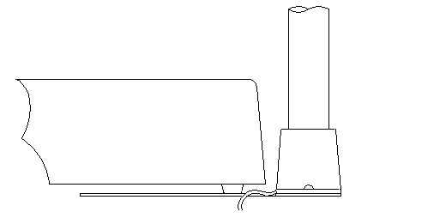

CASH
DRAWER

POLE
DISPLAY

MOUNTING
BRACKET
AND PLATE

Figure 2-1 Free Standing Pole Display

Option Two:
This option, shown in Figure 2-2, allows the user to install the pole display in a variety of ways. You may choose to install the display unit using just the mounting bracket, or with the mounting bracket attached to the center position of the mounting plate.

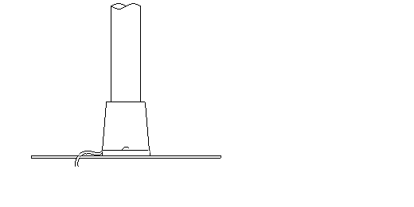

POLE
DISPLAY

MOUNTING BRACKET
WITH OR WITHOUT PLATE

Figure 2-2 Stand Alone Pole Display

After determining which option best suits your needs, begin the installation. Insert the interface cables, which come out of the bottom of the PD1100 PASS-THROUGH pole display, through the top of the mounting bracket. Insert the pole into the mounting bracket using a back and forth twisting motion to ensure a secure fit. Ensure that cable(s) clear all obstructions while inserting the pole into mounting bracket. Avoid placing pressure of any kind on the display head. The pole should be inserted until it reaches the bottom stop. The stop, as shown in Figure 2-3, is located ¼” from the bottom of the bracket.

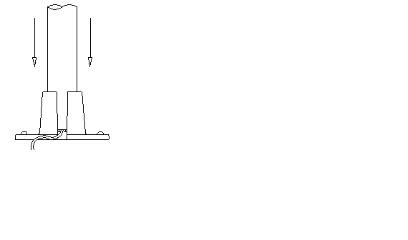

POLE
DISPLAY

MOUNTING
BRACKET

MOUNTING BRACKET
BOTTOM STOP

Figure 2-3 Inserted Pole Display
.

Serial / Parallel Connection

Attach the output and input connectors of the PD1100 PASS-THROUGH as shown in Figure 2-4. Now you are ready to perform the Power Up procedure.
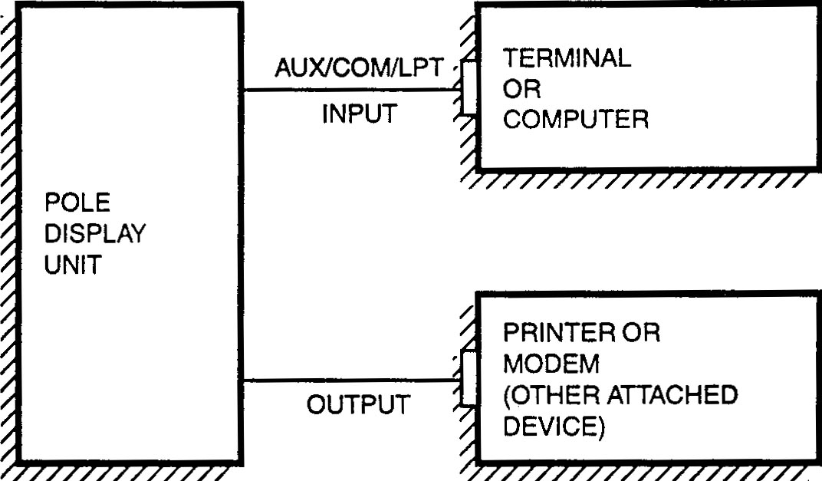

Figure 2-4 Typical PD1100 PASS-THROUGH Serial/Parallel Connections

Power Up

Place the wall transformer into a 120 volt AC power source.

A message appears on the display window and remains for a few seconds. This message is an indication of a successful power up.

First Message

Ultimate Technology
10xxx Prom ver xx.xx

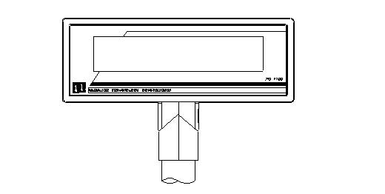
LEFT
RIGHT

DISPLAY WINDOW
DISPLAY WINDOW

Figure 2-5 The PD1100 PASS-THROUGH Pole Display Unit

PROGRAMMING

Introduction

The PD1100 PASS-THROUGH Pole Display operates by converting data supplied by a specific device into a displayed message. The supplied data may also contain commands that alter the way the message is displayed. The altered display functions vary, depending on the operating mode of the display unit. Table 3-1 lists the display functions and their availability with the operating modes of the PD1100 PASS-THROUGH.

The operating mode, along with program parameters, is selected at setup. PD1100 PASS-THROUGH setup and display control commands with descriptions are given in this section.

Table 3-1 The PD1100 PASS-THROUGH Display Functions
DISPLAY FUNCTION | UTC PASS-THROUGH MODE | DIRECT TO POLE MODE
- TOP LINEMESSAGE | <ESC>uA | N/A
- BOTTOM LINE MESSAGE | <ESC>uB | N/A
- TOP LINE CONTINUOUS SCROLLING | <ESC>uD | N/A
- SET/DISPLAY TIME | <ESC>uE | N/A
- TOP LINE 1 TIME SCROLL | <ESC>uF | N/A
- DISPLAY MENU BUTTONS | <ESC>uG<CR> | N/A
- BRIGHTNESS  x = 20h Dim x = 60h Medium  x = 40h Low x = FFh High | N/A | <EOT>x
- BACK SPACING | N/A | <BS>
- HORIZONTAL TAB | N/A | <HT>
- LINE FEED | N/A | <LF>
- CARRIAGE RETURN | N/A | <CR>
- DISPLAY POSITION | N/A | <DLE>
- NORMAL DISPLAY MODE | N/A | <DC1>
- VERTICAL SCROLL MODE | N/A | <DC2>
- PASS-THROUGH MODE | N/A | <ESC>d*
- DIRECT TO POLE MODE | <ESC><RS>* | N/A
- RESET DISPLAY | N/A | <US>
- FLASHING TEXT START | <SI> | <FS>
- FLASHING TEXT END | <SO> | <GS>
- CLEAR TO END OF LINE | N/A | <CAN>
- CLEAR TO END OF DISPLAY | N/A | <EM>
- DISPLAY FONTS  x = 01h American x = 05h French  x = 02h British Canadian  x = 03h German x = 06h Spanish  x = 04h French x = 07h PD220XL | <ESC>ulx<CR> | <SUB>x
- CLEAR DISPLAY | <ESC>uA<CR><ESC>uB<CR> | <RS>
- DOWN LINE LOAD | <ESC>utc | N/A
- REFEFINE GRAPHIC | <ESC>uH | N/A
- SEND VERSION STRING  *These (<RS> and ‘d’) can be changed in configuration to a  user specified code. | <ESC>uJ<CR> | N/A

Setup

Upon successful system Power Up, as described in Section 2, you can begin the PD1100 PASS-THROUGH Setup Menu Program. To enter the program, press both Menu Select buttons simultaneously. A message will appear on the display as described in Power Up. The Setup Menu Program is also used to change program parameters. Table 3-2 lists the menu items and program parameters accessed through the Setup Menu.

Pressing the right button (Menu Select #1), allows you to scroll through the menu items. Pressing the left button (Menu Select #2), allows you to scroll through the options. Refer to Figure 3-1.

Stopping at an option and pressing the right button, selects that option and moves the display to the next menu item. Upon completion and exiting the sequence, a message is given and within five (5) seconds the display goes blank.

Table 3-2 Setup Menu and Program Parameters

MENU ITEMS | OPTIONS
- RESET DEFAULTS | YES, NO*
- BAUD RATE | 300, 600, 900, 1200, 1800, 2400, 2880, 3600, 4800*, 6400, 7200, 9600  14.4k, 19.2k, 28.8k, 57.6k bps
- PARITY | NONE*, EVEN, ODD, MARK, SPACE
- BRIGHTNESS | DIM, LOW, MEDIUM*, HIGH
- START UP MODE | DIRECT TO POLE, UTC PASS-THROUGH*, EMAX SUBSET
- PASS-THROUGH ON CODE | 00h-7Fh (Hex Code – 64)*
- DIRECT TO POLE ON CODE | 00h-7Fh (Hex Code – 1E)*
- OUTPUT PORT | ENABLED*, DISABLED
- COMMAND TERMINATOR | CR ONLY*, LF ONLY, CR/LF PAIR
- HANDSHAKING | HARDWARE*, DISABLED
- CHARACTER SET | PD220XL*, AMERICAN, BRITISH, GERMAN, FRENCH, SPANISH,  FRENCH CANADIAN
- SAVE CHANGES NOW?  (Write to nvram now?) | YES, NO*
- EXIT SETUP NOW? | YES*, NO
*Default setting for each menu item in nonvolatile memory.

LEFT
RIGHT
DISPLAY WINDOW

Figure 3-1 Entering the Setup Menu Program

Operating Modes

The UTC Pass-Through Mode allows for all data to pass through to an attached device while allowing certain customer display commands to be active. Refer to Table 3-1 for display functions available with specific operating modes.

The Direct To Pole Mode allows direct communications to the pole only. To output to a second device, a software switch to UTC Pass-Through Mode should be used with a software switch back when pole output is again desired. Software switches are described in Section 3 under Display Control Command, items 15 (PASS-THROUGH MODE), and 16 (DIRECT TO POLE MODE).

Display Control Command

The following describes all display control features along with an example of their command and data sequence. When the control feature is available for UTC Pass-Through Mode, an example of the UTC command and data sequence is given.

<ESC>uAxxx…xxx<CR> TOP LINE
ALPHANUMERIC

The leftmost 20 characters, following the command terminated by a CR (Carriage Return), will be displayed on the top line.

NOTE: To clear top line use: <ESC>uA<CR>

<ESC>uBxxx…xxx<CR> BOTTOM LINE
ALPHANUMERIC

The leftmost 20 characters, following the command terminated by a CR (Carriage Return), will be displayed on the bottom line.

Note: To clear bottom line use: <ESC>uB<CR>
This will remove time from the display but the internal clock will continue to run.

<ESC>uDxxx…xxx<CR> TOP LINE
ONGOING ALPHANUMERIC
MESSAGE SCROLL

A message of up to 40 characters will be scrolled continuously on the top line of the display.

<ESC>uEhh:mm<CR> TIME DISPLAY
BOTTOM LINE

Time value (12 hour clock) will be shown on the bottom line in the format hh:mm:ss and continuously updated until cleared by a command to write to the bottom line.

Note: To re-display previously set time use: <ESC>uE<CR>

<ESC>uFxxx…xxx<CR> TOP LINE 1 TIME
ALPHANUMERIC
MESSAGE SCROLL

A message of up to 40 characters will scroll once on the top line.

<ESC>uG<CR> DISABLE MENU BUTTONS
UNTIL NEXT POWER UP

ASCII HEX DEC

<EOT>x 04 04 BRIGHTNESS

Upon receipt of a dimming command, subsequent characters will be at the brightness level selected. This level will remain until a new dimming command is received. Where x is the option byte:

 |  | Dim | Low | Medium | High
x | = | 20h | 40h | 60h | FFh

Table 3-3 Display Brightness Control Commands

Dimming Level | ASCII | DEC | HEX
100 %  60 %  40 %  20 % | -  ‘  @  Space | 255  96  64  32 | FF  60  40  20

ASCII HEX DEC

<BS> 08h 08 BACK SPACING

When the backspace command is executed the cursor position is shifted to the left one position, erasing the character, if any, that was in that position. When the cursor is in the first (read from left to right) position of the first row, the cursor moves to the last position of the second row. When the cursor is in the first position of the second row, the cursor moves to the last position of the first row.

ASCII HEX DEC

<HT> 09h 09 HORIZONTAL TAB

DC1 MODE
(Normal Display Mode)
The cursor position is shifted to the right one position. When the cursor is in the last position of the first row, the cursor moves to the first position of the second row. When the cursor is in the last position of the second row, the cursor moves to the first position of the first row.

DC2 MODE
(Vertical Scroll Mode)
When the cursor is in the last position of the second row, the characters displayed in the second row are shifted up to the first row and the cursor moves to the first position of the second row. This clears the second row.

ASCII HEX DEC

<LF> ØAh 10 LINE FEED

DC1 MODE
(Normal Display Mode)

The cursor moves up or down to the other row, staying in the same position.

DC2 MODE
(Vertical Scroll Mode)
When the cursor is in the second row, the character displayed there is shifted up to the first row, leaving the cursor at its present position. This clears the second row. When the cursor is in the first row, the cursor moves down to the second row.
ASCII HEX DEC

<CR> ØDh 13 CARRIAGE RETURN

The cursor moves to the first position of the same row.

ASCII HEX DEC

<DLE> 1Øh 16 DISPLAY POSITION

By using the display positioning function, the write-in starting position can be specified. After writing 10h to prepare the display for this command, another HEX byte is written to specify the position desired. A third byte representing data is then sent.

Character Position Chart (HEX)
ROW
1 | 00 | 01 | 02 | 03 | 04 | 05 | 06 | 07 | 08 | 09 | 0A | 0B | 0C | 0D | 0E | 0F | 10 | 11 | 12 | 13
2 | 14 | 15 | 16 | 17 | 18 | 19 | 1A | 1B | 1C | 1D | 1E | 1F | 20 | 21 | 22 | 23 | 24 | 25 | 26 | 27

ASCII HEX DEC

<DC1> 11h 17 NORMAL DISPLAY MODE

After writing a character, the cursor is shifted automatically to the right one position. When the cursor is in the last position of the first row, it moves to the first position of the second row. When the cursor is on the last position of the second row, the cursor moves to the first position of the first row.

ASCII HEX DEC

<DC2> 12h 18 VERTICAL SCROLL MODE

After writing the characters up to the last position of the second row, all characters displayed in the second row are shifted to the upper row (first row), clearing the second row. The Vertical Scroll Mode (DC2) is the default mode preset by the factory, and will be held until another mode is selected.

<ESC>d* PASS-THROUGH MODE

This command is used in Direct To Pole Mode to begin passing data through to the attached device. After this command is received, the display will be in UTC Pass-Through Mode.

To pass an <ESC>u sequence thru to the attached device, when in UTC Pass-Through Mode, send two <ESC>’s [i.e. <ESC><ESC>u..] and the data received by the device will be a single <ESC>u. If the escape sequence to be sent through does not begin with { ‘u’ or ‘<RS>’} then 2 escapes are not needed.

If <ESC><RS> must be sent to the printer then two options are possible:

Option 1:
Redefine the Direct To Pole Mode character to another code in lieu of <RS>.

Option 2:
Send <ESC><ESC><RS> and the device will receive <ESC><RS>.

*The Pass-Through Mode command may be changed on the setup menu to any character, in the range 00h through 7Fh.

<ESC><RS>* DIRECT TO POLE MODE

This command is used in UTC Pass-Through Mode to enter or return to Direct To Pole Mode. If any UTC Pass-Through Mode display commands have been used (other than Pass-Through data), the display will be cleared and reset to the last mode used in Direct To Pole Mode or to the default <DC2> (Vertical Scroll Mode).

If Pass-Through data is desired, use the command <ESC>d to enter UTC Pass-Through Mode, send data to the attached device, then switch back to Direct To Pole Mode with <ESC><RS>.

Note: To enter UTC Pass-Through Mode from Direct To Pole Mode, send a <ESC>d* or specify during setup. To enter Direct To Pole Mode from UTC Pass-Through Mode, send a <ESC><RS>* or specify during setup. In order to direct output to printer, a software switch to UTC Pass-Through Mode should be used with a software switch back when pole output is again desired.

* These commands may be changed on the setup menu to any character except ‘u’ in the range 00h to 7Fh.

ASCII HEX DEC

<US> 1Fh 31 RESET DISPLAY

The display will be cleared and reset to the default of <DC2> mode (Vertical Scroll). The cursor will be positioned to the first position on the top line.

Note: Since this command resets the display modes, if you wish to continue to use the display in <DC1> and/or <DC2> modes, you must reissue those commands after <US>.

ASCII HEX DEC FLASHING TEXT START

<SI> ØFh 15 in Pass-Through Mode
<FS> 1Ch 28 in Direct To Pole Mode

ASCII HEX DEC FLASHING TEXT END

<SO> ØEh 14 in Pass-Through Mode
<GS> 1Dh 29 in Direct To Pole Mode

These commands are used inside top and bottom line display commands in UTC Pass-Through Mode to flash text on the display. By surrounding the text to flash with <SI> CTRL-O and <SO>CTRL-N the text in between will flash.

Example in UTC Pass-Through Mode only:

<ESC>uD SPECIAL ON WIDGETS ONLY <SI>3.99<SO> PER POUND.<CR>

Example in Direct To Pole Mode only:

<US> SPECIAL ON WIDGETS <CR> <LF> ONLY <FS> 3.99
<GS> PER POUND.

ASCII HEX DEC

<CAN> 18 24 CLEAR TO END OF LINE

This command will clear out the display from the current write-in position to the end of the current line. The current write-in position will not change.

Direct to Pole Mode Only

ASCII HEX DEC

<EM> 19 25 CLEAR TO END OF DISPLAY

This command will clear out the display from the current write-in position to the end of the second line. The current write-in position will not change.

Direct to Pole Mode Only

<ESC>uI n <CR> SELECT FONT
n is ASCII digit ‘1’ – ‘7’ 1 American
- British
- German
- French
- French Canadian
- Spanish
- PD220XL

ASCII HEX DEC

<RS> 1Eh 30 CLEAR DISPLAY

These commands are used to clear the display and move the cursor to the home position without changing any modes in effect.

<ESC>utc{selection}<CR> DOWN LINE LOAD

In UTC Pass-Through Mode, the display can download the setup options without having to traverse through the setup menu manually. This command is useful when multiple displays are to be set up. Refer to Table 3-3 for the selections and data than can be entered into the download command set. The xx are substituted by the specific value required.

EXAMPLE:
To set Baud Rate to 9600 and Contrast to ####, send:

<ESC>utc A0B C03<CR>
CONTRAST
BAUD RATE
DOWNLOAD ENABLE COMMAND

These will be the only parameters changed.

Table 3-4 Command Set Data
SELECTION |  | BAUD RATE | xx |  | BAUD RATE | xx
Parallel | Serial
N/A | Axx | 300 | 00 |  | *4800 | 08
 |  | 600 | 01 |  | 6400 | 09
 |  | 900 | 02 |  | 7200 | 0A
 |  | 1200 | 03 |  | 9600 | 0B
 |  | 1800 | 04 |  | 14.4K | 0C
 |  | 2400 | 05 |  | 19.2K | 0D
 |  | 2800 | 06 |  | 28.8K | 0E
 |  | 3600 | 07 |  | 57.6K | 0F
SELECTION |  | PARITY | xx |  | PARITY | xx
Parallel | Serial
N/A | Bxx | *NONE | 00 |  | MARK | 03
 |  | EVEN | 01 |  | SPACE | 04
 |  | ODD | 02
SELECTION |  | CONTRAST | xx |  | CONTRAST | xx
Parallel | Serial
Cxx | Cxx | # | 00 |  | *### | 02
 |  | ## | 01 |  | #### | 03
SELECTION |  | START UP MODE |  |  |  | xx
Parallel | Serial
Dxx | Dxx | *UTC PASS-THROUGH MODE  DIRECTED TO POLE MODE  EMAX SUBSET |  |  |  | 00  01  02
SELECTION |  | PASS-THROUGH ON CODE |  |  |  | xx
Parallel | Serial
Exx | Exx | Xx=00h to 7Fh |  |  |  | 64h
SELECTION |  | DIRECT TO POLE ON CODE |  |  |  | xx
Parallel | Serial
Fxx | Fxx | Xx=00h to 7Fh |  |  |  | 30h
SELECTION |  | OUTPUT PORT |  |  |  | xx
Parallel | Serial
Gxx | Gxx | DISABLED |  |  |  | 00
 |  | *ENABLED |  |  |  | 01
SELECTION |  | TERMINATOR CHARACTER |  |  |  | xx
 | Serial
 | Hxx | CR |  |  |  | 00
 |  | LF |  |  |  | 01
 |  | CR/LF |  |  |  | 02
SELECTION |  | HANDSHAKE |  |  |  | xx
 | Serial
 | Ixx | Disabled |  |  |  | 00
 |  | Enabled |  |  |  | 01
*Default settings or parameters outside of above specified ranges.

<ESC>uH REDEFINE GRAPHIC
cc H1 H2 H3 H4 H5 H6 H7>RET>
(cc = character to change in Hex)

Allows the generation of custom character graphics. Defined below is the creation of a character “A”.

CHARACTER DOT POSITION

 |  | 7 | 6 | 5 | 4 | 3 | 2 | 1 | 0
 |  | 0 | 1 | 0 | Ο | Ο | ■ | Ο | Ο | H1
 |  | 0 | 1 | 0 | Ο | ■ | Ο | ■ | Ο | H2
 |  | 0 | 1 | 0 | ■ | Ο | Ο | Ο | ■ | H3
 |  | 0 | 1 | 0 | ■ | Ο | Ο | Ο | ■ | H4
 |  | 0 | 1 | 0 | ■ | ■ | ■ | ■ | ■ | H6
 |  | 0 | 1 | 0 | ■ | Ο | Ο | Ο | ■ | H6
 |  | 0 | 1 | 0 | ■ | Ο | Ο | Ο | ■ | H7
 |  | 7 | 6 | 5 | 4 | 3 | 2 | 1 | 0
H1 | = | 0 | 1 | 0 | 0 | 0 | 1 | 0 | 0 | or | 44h
H2 | = | 0 | 1 | 0 | 0 | 1 | 0 | 1 | 0 | or | 4Ah
H3 | = | 0 | 1 | 0 | 1 | 0 | 0 | 0 | 1 | or | 51h
H4 | = | 0 | 1 | 0 | 1 | 0 | 0 | 0 | 1 | or | 51h
H5 | = | 0 | 1 | 0 | 1 | 1 | 1 | 1 | 1 | or | 5Fh
H6 | = | 0 | 1 | 0 | 1 | 0 | 0 | 0 | 1 | or | 51h
H7 | = | 0 | 1 | 0 | 1 | 0 | 0 | 0 | 1 | or | 51h

<ESC>uJ SEND VERSION STRING

Sent to Pass-Through device.

Example: printer.

TECHNICAL INFORMATION

Cable Pinouts

The PD1100 PASS-THROUGH Pole Display cable connections can be configured to user specifications. Figures 4-1 and 4-2 show typical RS232 (serial) and Centronics (parallel) pinout data.

Note: All signals, except for TX, RX and DTR, are passed directly through. DTR is the only handshaking line monitored.

If the output cable is not connected to a modem or printer, it may be necessary to jump pins 4 to 5, and 6 to 20 in order to satisfy handshaking in your computer.

Serial Pinouts

PD1100 PASS-THROUGH-Serial
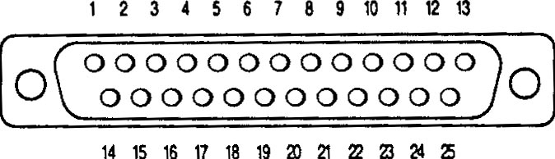

DB25 Male

 | Input |  | Output
1 | Chassis Ground | 1 | Chassis Ground
2 | TX Data | 2 | RX Data
3 | RX Data | 3 | TX Data
4 | RTS | 4 | RTS
5 | CTS | 5 | CTS
6 | DSR | 6 | DSR
7 | Signal Ground | 7 | Signal Ground
8 | DCD | 8 | DCD
20 | DTR | 20 | DTR

Figure 4-1 Typical Serial Pinouts

Parallel Pinouts

PD1100 PASS-THROUGH-Parallel

DB25 Male
(Input)
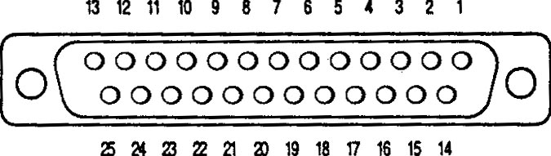

DB25 FEMALE
(Output)

1 | Strobe | 10 | ACK
2 | Data 0 | 11 | Busy
3 | Data 1 | 12 | Paper End (Low)
4 | Data 2 | 13 | Sict
5 | Data 3 | 14 | Auto LF
6 | Data 4 | 15 | Error
7 | Data 5 | 16 | Init
8 | Data 6 | 17 | Sict In
9 | Data 7 | 20-24 | Signal Ground

Figure 4-2 Typical Parallel Pinouts

ASCII Character Set

DEC | HEX | ASCII |  | DEC | HEX | ASCII |  | DEC | HEX | ASCII |  | DEC | HEX | ASCII
0 | 00 | Ctrl-@ (NUL) |  | 32 | 20 | Space |  | 64 | 40 | @ |  | 96 | 60 | `
1 | 01 | Ctrl-A (SOH) |  | 33 | 21 | ! |  | 65 | 41 | A |  | 97 | 61 | a
2 | 02 | Ctrl-B (STX) |  | 34 | 22 | “ |  | 66 | 42 | B |  | 98 | 62 | b
3 | 03 | Ctrl-C (ETX) |  | 35 | 23 | # |  | 67 | 43 | C |  | 99 | 63 | c
4 | 04 | Ctrl-D (EOT) |  | 36 | 24 | $ |  | 68 | 44 | D |  | 100 | 64 | d
5 | 05 | Ctrl-E (ENQ) |  | 37 | 25 | % |  | 69 | 45 | E |  | 101 | 65 | e
6 | 06 | Ctrl-F (ACK) |  | 38 | 26 | & |  | 70 | 46 | F |  | 102 | 66 | f
7 | 07 | Ctrl-G (BEL) |  | 39 | 27 | ‘ |  | 71 | 47 | G |  | 103 | 67 | g
8 | 08 | Ctrl-H (BS) |  | 40 | 28 | ( |  | 72 | 48 | H |  | 104 | 68 | h
9 | 09 | Ctrl-I (HT) |  | 41 | 29 | ) |  | 73 | 49 | I |  | 105 | 69 | i
10 | 0A | Ctrl-J (LF) |  | 42 | 2A | * |  | 74 | 4A | J |  | 106 | 6A | j
11 | 0B | Ctrl-K (VT) |  | 43 | 2B | + |  | 75 | 4B | K |  | 107 | 6B | k
12 | 0C | Ctrl-L (FF) |  | 44 | 2C | , |  | 76 | 4C | L |  | 108 | 6C | l
13 | 0D | Ctrl-M (CR) |  | 45 | 2D | - |  | 77 | 4D | M |  | 109 | 6D | m
14 | 0E | Ctrl-N (SO) |  | 46 | 2E | . |  | 78 | 4E | N |  | 110 | 6E | n
15 | 0F | Ctrl-O (SI) |  | 47 | 2F | / |  | 79 | 4F | O |  | 111 | 6F | o
16 | 10 | Ctrl-P (DLE) |  | 48 | 30 | 0 |  | 80 | 50 | P |  | 112 | 70 | p
17 | 11 | Ctrl-Q (DC1) |  | 49 | 31 | 1 |  | 81 | 51 | Q |  | 113 | 71 | q
18 | 12 | Ctrl-R (DC2) |  | 50 | 32 | 2 |  | 82 | 52 | R |  | 114 | 72 | r
19 | 13 | Ctrl-S (DC3) |  | 51 | 33 | 3 |  | 83 | 53 | S |  | 115 | 73 | s
20 | 14 | Ctrl-T (DC4) |  | 52 | 34 | 4 |  | 84 | 54 | T |  | 116 | 74 | t
21 | 15 | Ctrl-U (NAK) |  | 53 | 35 | 5 |  | 85 | 55 | U |  | 117 | 75 | u
22 | 16 | Ctrl-V (SYN) |  | 54 | 36 | 6 |  | 86 | 56 | V |  | 118 | 76 | v
23 | 17 | Ctrl-W (ETB) |  | 55 | 37 | 7 |  | 87 | 57 | W |  | 119 | 77 | w
24 | 18 | Ctrl-X (CAN) |  | 56 | 38 | 8 |  | 88 | 58 | X |  | 120 | 78 | x
25 | 19 | Ctrl-Y (EM) |  | 57 | 39 | 9 |  | 89 | 59 | Y |  | 121 | 79 | y
26 | 1A | Ctrl-Z (SUB) |  | 58 | 3A | : |  | 90 | 5A | Z |  | 122 | 7A | z
27 | 1B | Ctrl-[ (ESC) |  | 59 | 3B | ; |  | 91 | 5B | [ |  | 123 | 7B | {
28 | 1C | Ctrl-\ (FS) |  | 60 | 3C | < |  | 92 | 5C | \ |  | 124 | 7C | |
29 | 1D | Ctrl-] (GS) |  | 61 | 3D | = |  | 93 | 5D | ] |  | 125 | 7D | }
30 | 1E | Ctrl-^ (RS) |  | 62 | 3E | > |  | 94 | 5E | * |  | 126 | 7E | ~
31 | 1F | Ctrl-_ (US) |  | 63 | 3F | ? |  | 95 | 5F | _ |  | 127 | 7F | DEL

